GCP Professional Cloud Architect Exam

<https://tutorialsdojo.com/google-cloud-platform-gcp-cheat-sheets>

<https://github.com/sathishvj/awesome-gcp-certifications/blob/master/professional-cloud-architect.md>

<https://github.com/priyankavergadia/GCPSketchnote>

<https://github.com/priyankavergadia/google-cloud-4-words>

<https://grumpygrace.dev/posts/gcp-flowcharts/>

https://www.examtopics.com/exams/google/professional-cloud-architect/

# Architecture case studies

TerramEarth

https://www.youtube.com/watch?v=0G8hx9HUnbk&ab_channel=Sun%2CSea%26You

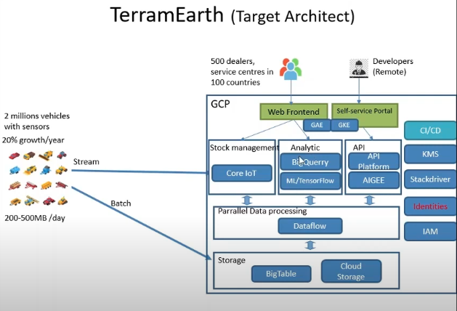

EHR

<https://www.youtube.com/watch?v=tSTDaMV8ZFc&list=PLiGDmIpNsrc3tOl-95mzKqXaHc3KoMblW&index=5&t=0s&ab_channel=Sun%2CSea%26You>

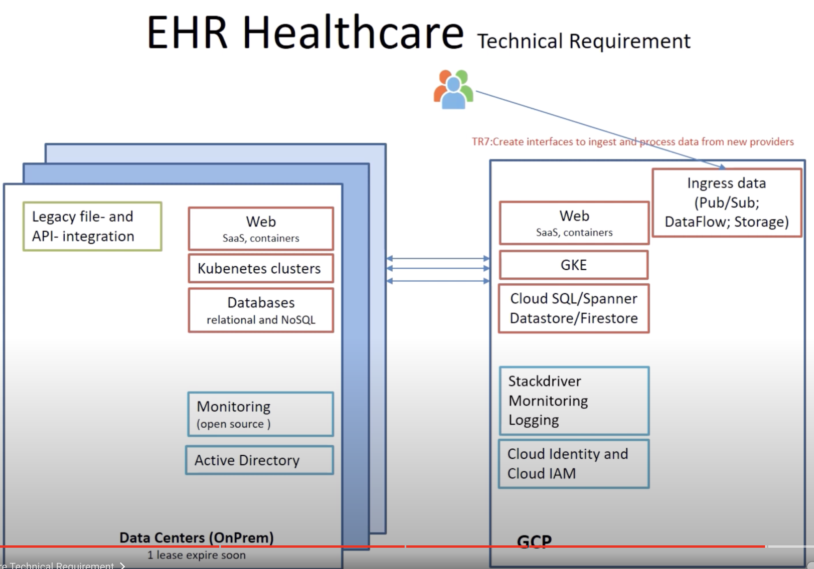

# Helicopter Racing League

<https://www.youtube.com/watch?v=659bnT9A2X8&t=7s&ab_channel=Sun%2CSea%26You>

Mountkirk

<https://www.youtube.com/watch?v=1w1olPjlPZY&ab_channel=Sun%2CSea%26You>

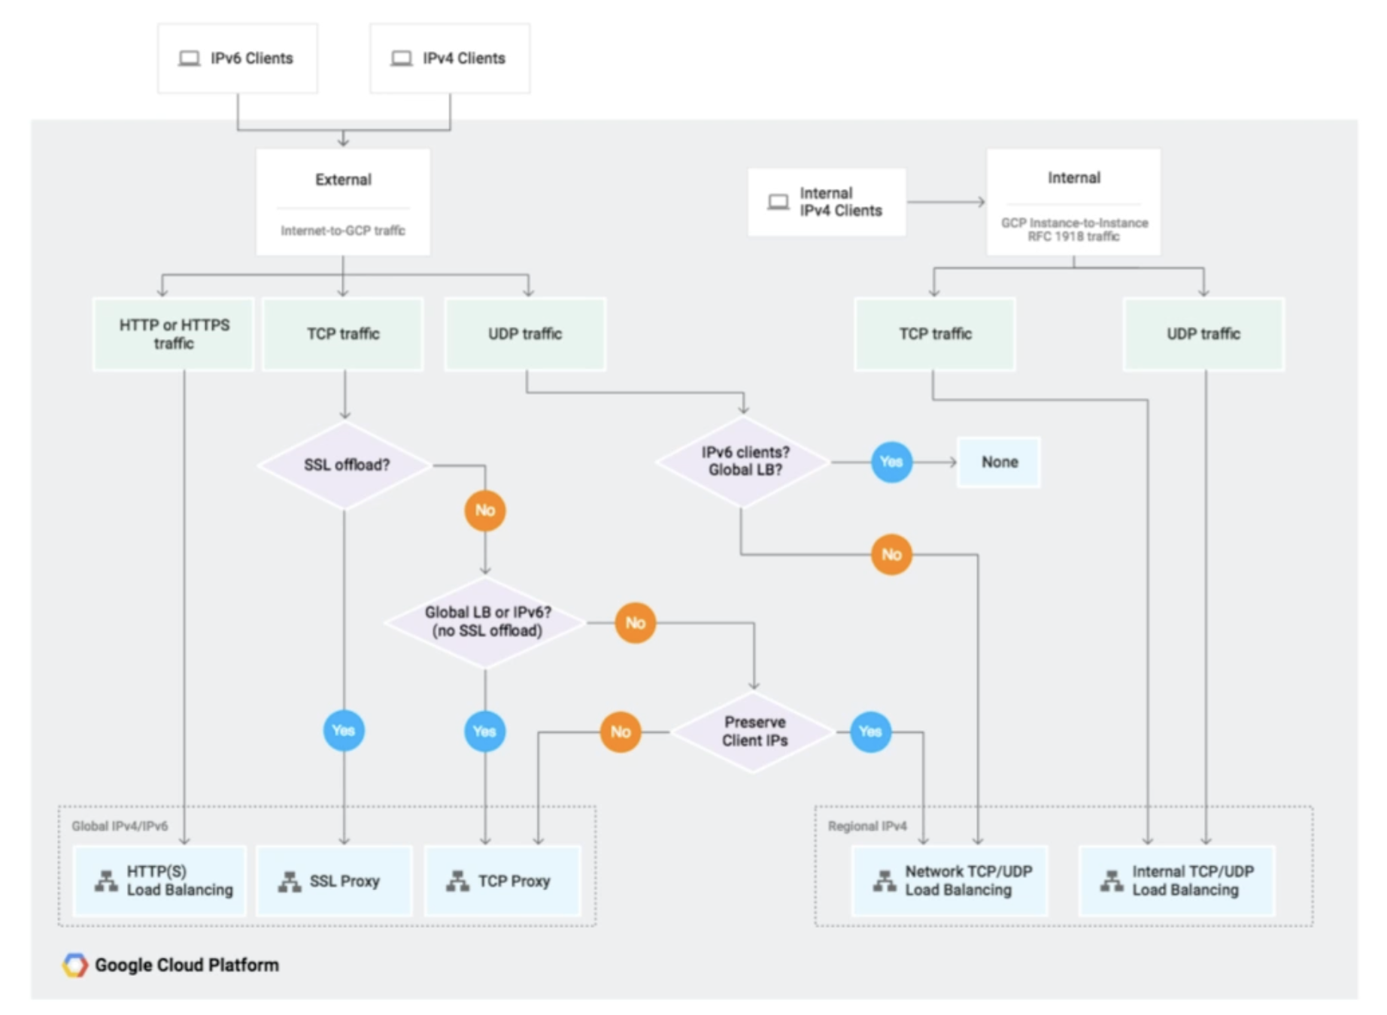

# How to select your the right compute option in Google Cloud?

# Dataproc

Managed service for apache Hadoop and spark.

# Dataflow

Unified stream and batch data processing.

# Datastore

Highly scalable NoSQL database.

# BigTable

Optimized for time-series data.